(Approx. 562 words)

Outlook.com
By Lynn Page, Newsletter Editor/Webmaster, Crystal River Users Group, FL
December 2012 issue, CRUG newsletter
www.crug.com
lpage46 (at) tampabay.rr.com

Microsoft has upgraded Hotmail and Windows Live to a new Outlook.com cloud email service. My accounts were just ‘upgraded’ this week. It is always hard to make changes so I will let you know what I have seen.

The introductory email has links to get started with Outlook where you can read information about the service, get a new email address, connect your account with your social media accounts and provide feedback. I have more than enough email addresses to keep track of and don’t want to connect my email with my Facebook accounts so didn’t even look at those options.

Interface
The Outlook interface has been streamlined from the Hotmail interface. It looks cleaner and takes less screen space. That can be important if you are checking email from a small portable devise.

One notable feature is that the menu bar only shows message items when an email or emails have been selected. Without that the only item is the New Message icon.

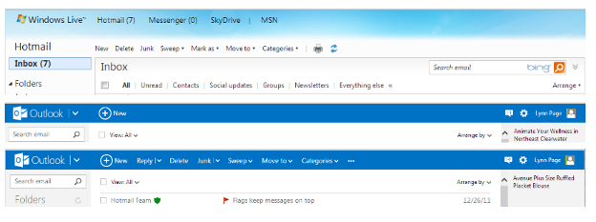

Further streamlining is seen in the filtering options. In Outlook to filter messages, click View All and select a filter category.

Another nice feature is the set of icons that are displayed when you mouse over a message. Click the icon to reply to, trash or flag the message.
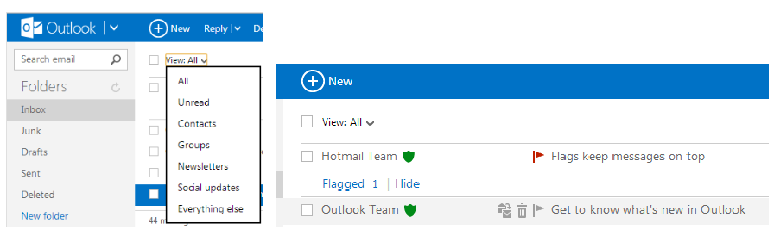

Outlook Folders and Quick Views are the same as in Hotmail. You can define rules to
automatically handle messages as they come in like flagging messages, moving them to folders and setting alerts for your mobile phone. Quick Views automatically sorts and
shows items by category.

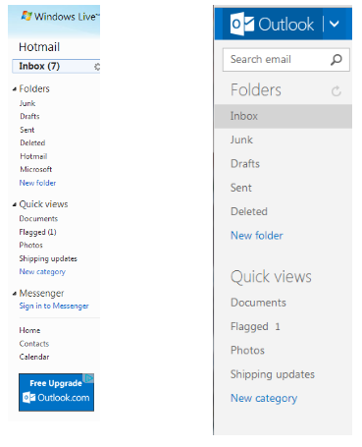
Cleaning up
I try to keep my Inbox, Sent and Deleted folders clean. This means that I either delete email from my Inbox or save to an offline folder on a regular basis. I also delete Sent emails and empty the Deleted folder ever few days. If you don’t want to take care of this yourself use Sweep or schedule a cleanup. Sweep works based on the email sender. Schedule a cleanup lets you select to keep only the latest email from a sender and delete the rest, delete all messages after 10 days or move them to a selected folder. Sweep can also delete emails in bulk from multiple senders, cleaning out hundreds of emails in seconds. It will also move all email from a sender to a specified folder.
If you tend to subscribe to every newsletter that comes along only to find out you
don’t read them Unsubscribe is great feature.

Set simple rules in Sweep to automatically file emails from specific senders to a
folder of your choice. The email won’t even go to the inbox. Sweep lets you file
emails straight to a folder automatically based on the sender's email address.

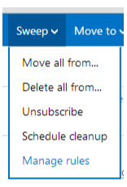

Office Online and SkyDrive
Outlook is designed to work seamlessly with Microsoft’s free Office Web Apps. So you can open, edit, and share Office files right from the inbox. This is great if you or the recipient is using a computer without Office installed. Integration with SkyDrive makes sharing and saving your files simple in 7 GB of free storage space. To share files place them in SkyDrive and email a link. Recipients can see photos and documents, even if they don't have Office on their computer.

